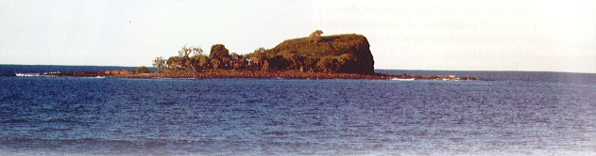
Ecosystems – Why do we need them?
(read, and answer the questions on the following page)

The island in the photo above is a few kilometres from the mainland. Over the years it has been colonised by many types of plants, as well as animals such as lizards, native mice, small wallabies and many types of insects and birds. This island can be described as ecosystem because there is a complex system of relationships between the organisms and with the non-living part of the environment.

The survival of an organism depends not only on its ability to get food and be protected from predators, competitors and disease-causing organisms, but also on the supply of water and air, a suitable temperature and weather conditions, and good soil.

The factors that affect the survival of an organism in its living place can be grouped into two categories – biotic or living factors and abiotic non-living factors.

The biotic factors in an ecosystem are all the living things that interact with an organism – the availability of food, the presence of predators and competitors, and the organism’s ability to ward off disease-causing organisms.

The abiotic factors include temperature, light, and humidity, the availability of air and water, and soil fertility. These factors are extremely important for the survival of any organism. For example, microscopic algae (plankton) are found only in the surface waters of the ocean where there is sufficient light for photosynthesis. And many reptiles and amphibians will hide away in logs or holes in the ground when the air temperature falls in winter.

The earth is full of ecosystems like the one described above. Some are large and some are very small. The one thing that all ecosystems have in common is the interdependence of all the organisms within the ecosystem. Most ecosystems collapse or change drastically if the number and type of organisms in them changes. This is why scientists study ecosystems in such detail. By understanding ecosystems, scientists hope to be able better predict the effect of change we make to the earth – like global warming, deforestation and pollution.

Questions

1. Given that the island is more than a kilometre from the coast, how do you think the animal species which exist there first made it to the island?

2. Briefly describe the difference between Biotic factors and Abiotic factors?

3. List all the abiotic factors which are mentioned in the article.

4. Describe in one or two sentences why we (humans) should care about ecosystems.

